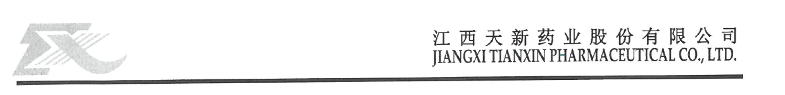
CERTIFICATE OF ANALYSIS

Product name: Vitamin B1 (Thiamine Mononitrate) Batch No: TM2602118
Manufacturing date | FEB,27,2026 | Reporting date | FEB,28,2026
Exp date | FEB,27,2029 | Article No. | 06102
Package | 25 kg per drum | Order No | 26-26
Executive Standard | USP2025 | Quantity | 1000 Kg

Test Item | Specification | Result
Appearance | White or almost white crystals or crystalline powder | almost white crystalline powder
Solubility | Sparingly soluble in water, slightly soluble in alcohol, very slightly soluble in chloroform | Comply
Identification | Meet the requirement  IR, Physical and chemical identification | Comply
Assay | 98.0~102.0 | 99.5
pH | 6.0~7.5 | 7.2
Loss on Drying | ≤1.0 | 0.26
Residue on Ignition | ≤0.2 | 0.04
Chloride and Sulfate | ≤0.06 | <0.06
Related Compounds | ≤1.0 | 0.53
Residual Solvent (Methanol) | ≤3000 | Not detected
Conclusion: The batch complies with the specification of USP2025
Remake: preserve in a tightly closed container, protected from light.

